­

P.O Box 63

P.O Box 6

**UNIVERSITY OF BUEA**

**SCHOOL MANAGEMENT SYSTEM: ACADEMIA VERSION 2**

University of Buea

Prof Elie Fute T.

***Supervisor***

CAMEROUN

Buea, Sud Quest Region

**REPUBLIQUE DU CAMEROUN**

P.O Box 63

**REPUBLIC OF CAMEROON**

**Option:** Software Engineering

Matriculation Number: FE21A266

***Professional Supervisor***

Mr Kofi Mokome

Zinger Systems Limited

NGWASIRI RYAN TANIFORM ONGA

**By :**

**Academic Year 2024/2025**

*Internship Report Submitted to the Department of Computer Engineering, Faculty of Engineering and Technology, University of Buea, in Partial Fulfilment of the Requirements for the Award of the Bachelor of Engineering (B.Eng.) Degree in Computer Engineering*

**ACADEMIA VERSION 2**

**DEPARTMENT OF COMPUTER ENGINEERING**

**FACULTY OF ENGINEERING AND TECHNOLOGY**

PAIX - TRAVAIL - PATRIE

CAMEROON

Buea, South West Region

P.O Box 63

PEACE – WORK - FATHERLAND



**DEDICATION**

I dedicate this report to my family, whose unwavering support and encouragement have been a constant source of motivation throughout my internship journey. Their belief in me has helped me navigate the challenges and embrace the opportunities that came my way.

**ACKNOWLEDGEMENTS**

I want to begin by expressing my deepest gratitude to God for His guidance and blessings throughout my journey, enabling me to complete this internship successfully.

My sincere thanks to Zinger Systems Limited and co-founder Mr. Valery Colong for providing me with the opportunity to learn and grow professionally. I am especially grateful to my technical supervisor, Mr. Kofi Mokome, whose expertise, guidance, and support were invaluable during my time at the company.

I also appreciate the efforts of my academic supervisor, Prof. Elie Fute, who gave me guidance on the creation of this report and the structuring of its content.

I want to extend my heartfelt thanks to all the employees at Zinger Systems Limited, whose teamwork, support, and shared knowledge made my internship experience meaningful. Their contributions enriched my learning process and enabled me to develop practical skills in software engineering.

Finally, I would like to thank my family and friends for their constant support and encouragement. Their belief in me gave me the strength to overcome challenges and succeed in this internship.

**DISCLAIMER**

This internship report provides a general overview of the tasks undertaken during my time at Zinger Systems Ltd. The primary focus of my work was contributing to the development of the company's proprietary software. Due to the non-disclosure agreement (NDA) signed by all interns, specific details regarding the system, including UI/UX designs, essential classes in class diagrams, and backend architecture, have not been disclosed.

Additionally, the software developed during this period is the intellectual property of Zinger Systems Ltd., and all rights are protected under copyright laws. Unauthorized use, reproduction, or distribution of this software is strictly prohibited.

**TABLE OF CONTENT**

Chapter 1: Introduction 1

1.1 Definition of Internship 1

1.2 Goals and Objectives of the Internship 1

1.3 Posting/Application for Internship 2

1.3.1. Finding the Internship 2

1.3.2. Application Process 2

1.3.3. Acceptance and Duration 3

1.4 Company Presentation 3

1.4.1 Company Introduction 3

1.4.2 Objective of the Company 3

1.4.3 History of the Company 4

1.4.4 Organizational Structure 4

1.4.5 Activities/Services Provided by the Company 6

1.5 Relevance of the Internship to Academic and Career Goals 6

Chapter 2: Internship Activities 7

2.1 First Day at Internship 7

1. Orientation and Office Introduction 7

2. Project Briefing: Academia Version 2 7

3. Onboarding to Tools and Resources 7

4. Setting Up the Development Environment 8

5. Team Interactions 8

2.2 Technical Supervisor 8

2.2.1. Technical Supervisor Name and Position 8

2.2.2. Guidance and Mentorship Throughout the Internship 8

2.3 Departments Assigned and Function 9

2.4 Tasks Assigned 9

2.4.1. Zinger Systems Entry Tasks 9

2.4.2. Preliminary Task 13

2.4.3. Main Project: Academia V2 15

2.4.2.1. Introduction 15

2.4.2.2. Background and Evolution of Academia 15

2.4.2.3.1. Problem Statement 15

2.4.2.3.2. Requirement Gathering 16

2.4.2.3.3 Functional Requirements of Academia V2 17

2.4.2.3.4. Non-Functional Requirements 18

2.4.2.3.5 Tech Stack of Academia V2 19

2.4.2.4 System Design 20

2.4.2.4.1 Use Case Diagram 22

2.4.2.4.2 Use Case Diagram Description 23

2.4.2.4.3. Class Diagram 26

A. Classes, Attributes and Methods 27

2.4.2.5. Tasks Performed on Academia V2(Implementation) 29

I. Frontend Tasks 29

II. Backend Tasks for Academia V2 33

2.5 Task Execution 34

I. Planning 34

II. Methodology 34

III. Architecture 34

2.6 Workplace Relationships 35

Chapter 3: Extra-Curricular Activities 36

3.1 Activities Organized by the Company 36

3.2 My Role in the Activities 36

3.3. Administrative Task with Managers 37

3.4. Lessons and Benefits 37

Chapter 4: Difficulties and Challenges Encountered 38

Chapter 5: Conclusion and Recommendations 39

5.1. Conclusion 39

5.2 Recommendations 39

5.2.1 For the Company: 39

5.2.2 For Future Interns: 39

5.2.3 For Academic Institutions: 39

References 40

Appendices 41

**Table of Figures**

Figure 1;Zinger Systems Organigram 5

Figure 2: Food Manager App 12

Figure 3: Quasar Crud Application Product Listing Page 14

Figure 4: Use Case Diagram 22

Figure 5: Academia V2 Class Diagram 25

Figure 6: Academia Login Page 28

Figure 7:Hostel/Dormitory Occupancy Widget 29

Figure 8: Level Listing Page with Sidebar Menu 30

Figure 9:Academia Admin School Dashboard 31

Figure 10: Quasar CRUD App (Creating Product) 40

Figure 11: Quasar CRUD App (Update Product) 40

Figure 12: Gaudian Model (Form Active Mode) 41

Figure 13: Staff Overview Widget 41

Figure 14: Student Enrollment Widget 42

Figure 15: Academia Admin Dashboard (School Setup) 42

Figure 16: Academia Level Schedular Pop-up Modal 43

Figure 17: Working day at the office 43

Figure 18: End of Year Outing (Extracurricular Activity) 44

**List of Tables**

Table 1: Entities Synonym names across University, Secondary and Primary Schools 21

Table 2: Relationship Between Actors 25

Table 3: Classes, Attributes and Methods 28

**LIST OF ABBREVIATIONS**

**1. UI/UX Design: User Interface/User Experience Design**

UI focuses on the visual layout of an app or website, while UX ensures the product is user-friendly and provides a seamless experience.

**2. B.E.M Architecture: Block-Element-Modifier Architecture**

A CSS methodology for organizing styles by breaking interfaces into blocks, elements, and modifiers to ensure reusable and scalable code.

**3. C.V.(Curriculum Vitae) :** A document summarizing education, skills, and work experience, used to apply for jobs or internships.

**4. E.R. Diagram: Entity-Relationship Diagram:** A visual representation of data in a database, showing entities (objects), their attributes, and relationships.

**5. V2: Version 2:** The second iteration of a product incorporates improvements and new features.

**6. CRUD: Create, Read, Update, Delete**

A set of operations on an application implies a user can create, read, update, and delete an entity.

**7. SOLID Principle:**

1. **Single Responsibility Principle (SRP):** A class should only do one thing. Don’t mix different jobs in one place.
2. **Open/Closed Principle (OCP):** You should be able to add new features without changing the old code.
3. **Liskov Substitution Principle (LSP):** You should be able to replace a part of your code with something else without breaking it.
4. **Interface Segregation Principle (ISP):** Don’t make classes do things they don’t need to do.
5. **Dependency Inversion Principle (DIP):** Big parts of your code shouldn’t depend directly on smaller parts. Use general rules instea

# 

# Chapter 1: Introduction

## 1.1 Definition of Internship

This report details an internship at Zinger Systems Limited in Buea, Cameroon, from June 7, 2023, to January 7, 2024. The internship involved working on both the frontend and backend of Academia, a school management software used by schools across Cameroon.

The experience was hands-on, with plenty of collaboration with developers and fellow interns. It wasn’t just about writing code, it was about solving real problems, improving workflows, and making sure the software met the needs of schools. Along the way, technical skills were sharpened, teamwork became second nature, and problem-solving took on a whole new meaning.

Beyond just coding, this internship highlighted how the right tools, when used effectively, can create innovative solutions that truly make a difference. It was an opportunity to learn, grow, and contribute to a meaningful project, leaving a lasting impact on both personal and professional development.

Internships offer a practical link between academic learning and real-world work, helping participants gain skills, experience workplace dynamics, and grow professionally. This program helped me apply my theoretical knowledge, improve my skills as a full-stack developer, and get ready for future challenges in tech.

## 1.2 Goals and Objectives of the Internship

Internships aim to serve both educational and professional purposes, which include:

* **Applying Academic Knowledge:** Interns get an opportunity to bridge the gap between theoretical concepts learned in classrooms and their practical application in real-world scenarios.
* **Skill Development:** Enhance technical, analytical, and interpersonal skills required to succeed in the professional world.
* **Career Exploration:** Provide interns with exposure to specific career paths, helping them make informed decisions about their future aspirations.
* **Professional Networking:** Foster relationships with industry professionals, mentors, and peers, which can be instrumental in career growth.
* **Understanding Workplace Culture:** Learn about workplace ethics, team dynamics, time management, and organizational structures.
* **Contributing to Organizational Goals:** Participate in meaningful projects and deliver value to the host organization while gaining invaluable experience

## 1.3 Posting/Application for Internship

Securing an internship at Zinger Systems Limited involved a systematic process,this process included the following:

### 1.3.1. Finding the Internship

I discovered this opportunity through the management and marketing officer. Zinger Systems was a compelling choice due to its reputation for rendering quality services such as Motowa and its innovative environment.

### 1.3.2. Application Process

The application process for my internship at Zinger Systems Limited was organized to test my skills and prepare me for the work ahead. It included submitting documents, completing tasks, and integrating into the company’s communication system. Here is a run down of the application process:

**1. Submission of CV and Internship Documents with Interview Process**

. I submitted my CV and internship documents from my faculty, detailing my education, technical skills, and achievements. During the interview, I discussed personal projects, shared my GitHub portfolio, and explained how I evaluated my skills.

**2. Joining Communication Platforms**

After the interview, the other interns and I joined the company’s communication channels, including WhatsApp groups, Gmail, Discord servers, and Skype. These platforms were used for sharing updates and staying connected with the team.

**3. Completing Assigned Entry Tasks**

To demonstrate our skills, we were given three entry-level tasks to accomplish to test how much we knew *(these tasks will be discussed more in Chapter 2)*

**4. Starting the Internship**

Once I completed these tasks, my internship officially began. These activities helped me prepare for the real projects I would work on and allowed me to transition smoothly into the company.

### 1.3.3. Acceptance and Duration

Following the successful application, I was offered a position to intern from July 7th, 2024 to January 7th, 2024, spanning 6 months. This time frame allowed me to immerse myself in diverse tasks and projects at Zinger Systems

## 1.4 Company Presentation

This section presents the company of the concerned internship along with its objectives and organizational structure.

### 1.4.1 Company Introduction

Zinger Systems Limited is a technology company based in Buea, Cameroon, specializing in software development and IT solutions. The company focuses on building scalable and innovative applications tailored to the needs of businesses and institutions. With expertise in web and mobile development, Zinger Systems Limited delivers high-quality software solutions, including Academia, a school management system designed to streamline administrative and academic processes.

The company fosters a collaborative work environment, emphasizing continuous learning, problem-solving, and the application of modern technologies. By leveraging agile methodologies and industry best practices, Zinger Systems Limited ensures efficient project execution and client satisfaction.

### 1.4.2 Objective of the Company

Zinger Systems Limited’s mission is to deliver high-quality, innovative IT solutions that address business challenges and drive digital transformation. The company is committed to:

* Developing customized software solutions for enterprises.
* Empowering businesses through technology and automation.
* Providing professional IT consultancy to foster growth and efficiency.

Their vision is to remain at the forefront of technological advancements, helping organizations achieve their objectives through seamless, reliable, and sustainable solutions.

### 1.4.3 History of the Company

Zinger Systems Limited, headquartered in Buea, Cameroon, is a full-fledged IT service provider specializing in enterprise web and mobile solutions development. The company covers all stages of the software development life cycle, including business analysis, design, prototyping, implementation, quality assurance, and post-project maintenance and support.

The company was founded by Fua Tse, who serves as the Co-Chief Executive Officer alongside Valery Colong in 2010. Over the years, Zinger Systems has established itself as a key player in the IT consulting and outsourcing industry, delivering high-quality software solutions to clients.

Throughout its history, Zinger Systems has maintained a commitment to innovation and excellence, continually adapting to the evolving technological landscape to meet the diverse needs of its clientele.

### 1.4.4 Organizational Structure

The company is organized into several key departments:

* **Management:** Provides strategic direction and oversees overall operations.
* **Development Team:** Responsible for software and mobile app creation.
* **DevOps:** Handles system integration, infrastructure, and automation.
* **Quality Assurance:** Ensures product quality through rigorous testing and feedback.
* **Support Team:** Offers customer and technical support to clients.

The following diagram shows the structure of the company in a hierarchal order across their various levels

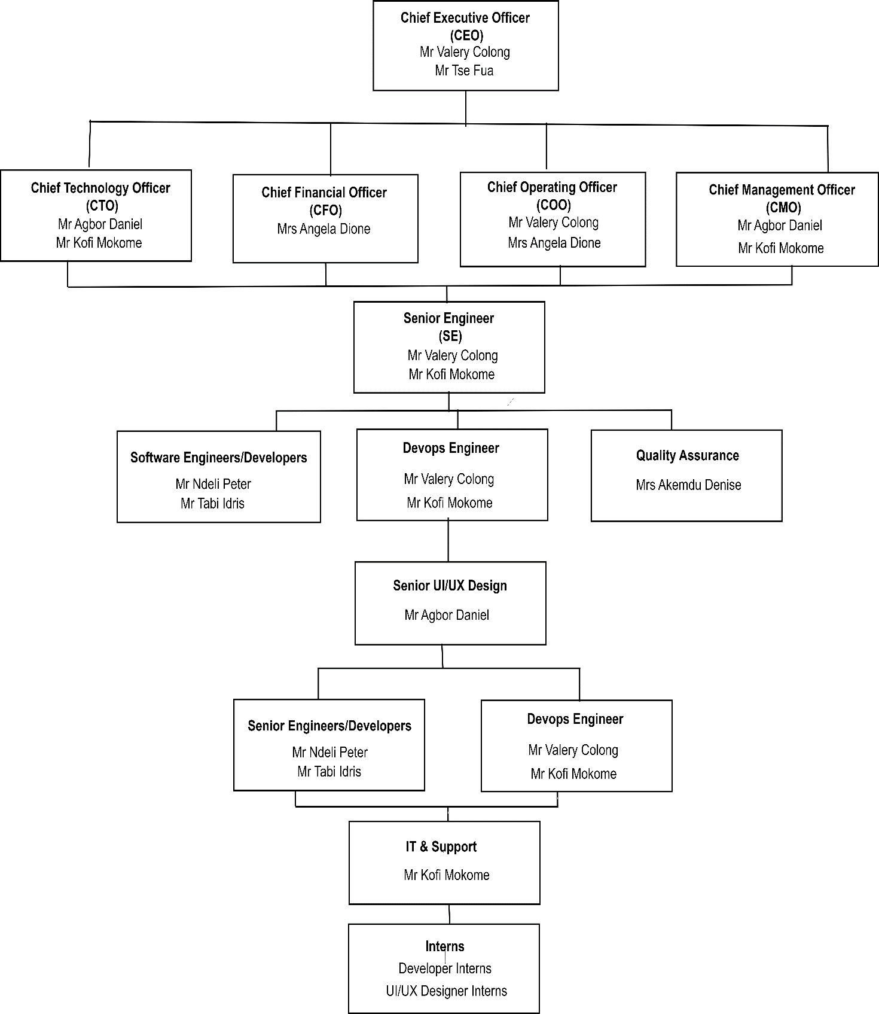

Figure 1;Zinger Systems Organigram

### 1.4.5 Activities/Services Provided by the Company

Zinger Systems Limited offers a wide range of services, including:

* **Custom Software Development:** Designing and implementing tailored solutions for businesses.
* **Mobile Application Development:** Creating user-friendly apps for Android and iOS platforms.
* **IT Consultancy:** Advising clients on leveraging technology to optimize operations.
* **Digital Marketing Services:** Providing online marketing strategies to enhance brand visibility.
* **Enterprise Solutions:** Developing ERP systems for efficient resource management.

## 1.5 Relevance of the Internship to Academic and Career Goals

The internship at Zinger Systems Limited was a pivotal step in aligning my academic studies with my career aspirations.

* **Academic Relevance:** It provided a platform to apply theoretical knowledge from my coursework to real-world projects.
* **Skill Acquisition:** Working with the development team allowed me to enhance my skills in web development and app development, teamwork, and problem-solving.
* **Career Preparation:** The experience solidified my interest in pursuing a career in [your chosen field, e.g., software development or IT consultancy], equipping me with the confidence to tackle future challenges.
* **Networking and Mentorship:** The internship helped me build professional connections and receive guidance from experienced mentors.

This chapter introduced the internship at Zinger Systems Limited, covering the company’s background, application process, organizational structure, and internship objectives. It also outlined the scope of work, providing a foundation for the detailed exploration of tasks, responsibilities, and technical contributions in the following chapters.

# Chapter 2: Internship Activities

This chapter gives a closer look at the work done during the internship at Zinger Systems Limited. It highlights the projects tackled, the skills applied, and the technologies used. Beyond just coding, it reflects on the collaborative effort with teammates, the problem-solving moments, and the hands-on experience gained in both frontend and backend development. It also explores how real-world software development goes beyond just writing code, it’s about teamwork, adaptability, and finding the right solutions.

## 2.1 First Day at Internship

My first day at the company was a structured and insightful experience, introducing me to the office environment, project expectations, and technical workflows. The activities on the first day include:

### 1. Orientation and Office Introduction

I was warmly welcomed and participated in an orientation session, where I was introduced to working hours, break schedules, office rules and practices, office culture, and daily routines.

### 2. Project Briefing: Academia Version 2

During the onboarding session, we were briefed on our primary project, Academia V2. Academia is a school management system that simplifies and digitizes school operations. Its purpose is to:

* Automate repetitive tasks, saving time and effort.
* Streamline data retrieval, making statistical and academic information easily accessible.
* Produce detailed academic reports quickly and efficiently.
* The system enhances organization and operational efficiency for schools.

We were introduced to the technologies that form the foundation of Academia Version 2, categorized into frontend and backend components:

### 3. Onboarding to Tools and Resources

We shared our Gmail accounts to access the GitLab repository containing the Academia Version 2 Quasar Project. The repository featured multiple branches for code management, including overviews, pulls, commits, pushes, and merges, all overseen by the lead developer. Additionally, we accessed the Academia Figma designs, which provided visual guidance for ensuring development aligned with the desired user interface and experience.

### 4. Setting Up the Development Environment

Our initial technical task involved setting up the development environment for Academia Version 2. This included pulling the frontend and backend code from the Academia Quasar Project, installing dependencies, configuring Docker for backend services, and running the server locally to verify

### 5. Team Interactions

I had opportunities to interact with team members who offered valuable insights into the company’s workflow and collaborative dynamics.

The first day was informative and engaging, equipping me with the knowledge and tools to effectively contribute to Academia Version 2.

## 2.2 Technical Supervisor

### 2.2.1. Technical Supervisor Name and Position

My technical supervisor, Mr. Kofi Mokome, is a Senior Software Engineer for the development team.

### 2.2.2. Guidance and Mentorship Throughout the Internship

As the Technical Lead, Mr. Kofi Mokome played a pivotal role in ensuring my successful onboarding, skill development, and contribution to the team. They provided technical guidance and oversight in the following areas:

1. **Project Onboarding:** I was introduced to Academia Version 2’s goals, structure, codebase, and GitLab workflows during the first week.
2. **Technical Guidance:** Clear explanations of the tech stack (Vue.js, Quasar, Parse Server, Firebase, Docker) and weekly check-ins helped me tackle tasks like CRUD operations, local storage management, and debugging.
3. **Code Review:** Regular feedback ensured my code was efficient, clean, and aligned with project standards and Figma-based UI/UX guidelines.
4. **Problem-Solving:** Mentors encouraged independent problem-solving while offering support when needed, fostering confidence and growth.

Their mentorship was a defining aspect of my internship, contributing greatly to my professional growth

## 2.3 Departments Assigned and Function

Full stack web development was undertaken, focusing on the implementation of responsive user interfaces and their integration with a dynamic backend. This experience enhanced frontend skills and adaptability to an evolving development process. Additionally, CRUD operations were performed on multiple models using framework-based code, along with backend functionalities such as filtering, analysis, and querying to support data manipulation and retrieval.

## 2.4 Tasks Assigned

This section outlines the various tasks assigned during the internship, including both entry tasks and the main project. These tasks were crucial in providing practical experience and enhancing the skills necessary for effective software development.

### 2.4.1. Zinger Systems Entry Tasks

To successfully join the company, I completed several critical tasks as part of the onboarding process. These tasks were instrumental in ensuring I was well-prepared to contribute effectively from the start. Below is a summary of the steps I took to enter the company:

**1. Frontend Dashboard Development**

One of the entry tasks assigned during the internship was to create an interactive and responsive admin dashboard. This project aimed to assess and enhance frontend development skills, particularly in JavaScript and served as a foundational task to demonstrate proficiency in relevant technologies.

**Technologies/Tools Used**

* **Next.js**: This React framework was employed for building the dashboard, allowing for server-side rendering and improved performance. Next.js facilitated the development of dynamic and scalable web applications that met project requirements.
* **Tailwind CSS:** A utility-first CSS framework used to style the dashboard components quickly and effectively. Tailwind CSS allowed for rapid prototyping and customization, ensuring a modern and polished look for the user interface.
* **Local Storage API:** This browser feature was used to manage user session data and preferences, ensuring that the dashboard retained relevant information across sessions.

This entry task was important for several reasons:

* **Proficiency in JavaScript Frameworks:** It showcased skills in JavaScript frameworks, especially Next.js, demonstrating knowledge of modern frontend development.
* **Assessment of Knowledge:** The project evaluated key frontend concepts like responsive design and user interactivity, highlighting both technical skills and a focus on user experience.

**2. Study and Implementation of BEM Architecture**

This task focused on understanding the Block Element Modifier (BEM) methodology, which is essential for enhancing the scalability and maintainability of CSS in web development. By studying BEM, the aim was to adopt a structured approach to writing CSS that promotes consistency and reusability across projects.

**Technologies/Tools Used:** SCSS and BEM guides were utilized to implement this architecture effectively. SCSS, a powerful CSS preprocessor, was leveraged to enhance the organization of styles, making it easier to manage and update the codebase.

Significance

This task was significant for several reasons:

* **Improved CSS Scalability:** Implementing BEM facilitated the creation of modular and reusable CSS components, making it easier to scale the application as new features are added.
* **Enhanced Maintainability:** By following the BEM methodology, the CSS code became more readable and maintainable, reducing the complexity of styles and making it simpler for other developers to understand and collaborate on the project.
* **Professional Development:** Gaining proficiency in BEM and SCSS represents a valuable addition to the skill set, aligning with best practices in modern web development and contributing to higher quality code in future projects.

**3. Frontend Food Manager Mobile App**

The primary goal of this task was to develop a mobile application based on the UI design provided by the company. The application enables users to create, update, and track tasks in real time, specifically focusing on managing household food ingredients. It includes a food ingredient listing page and a dedicated page for adding new ingredients.

**Technologies/Tools Used:**

* React Native
* Expo
* Tailwind CSS

**Significance**

This project served as a critical entry task for onboarding at Zinger Systems Ltd., specifically designed to assess skill levels and productivity. By successfully developing the application, it showcased proficiency in frontend technologies and demonstrated the ability to translate design specifications into functional, user-friendly interfaces.

Furthermore, this task not only tested technical capabilities but also emphasized the importance of efficient task management in everyday life. It reflects the company’s commitment to creating practical solutions that enhance user experience, ultimately contributing to a more organized and efficient approach to managing household ingredients.





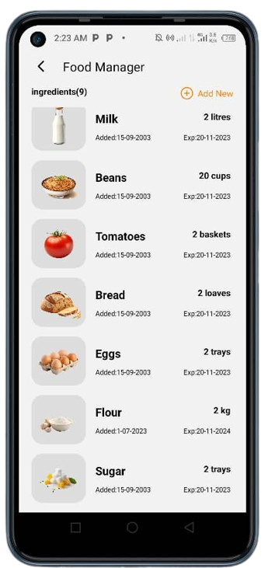

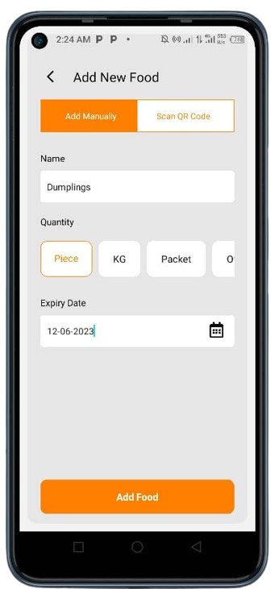



Figure 2: Food Manager App

### 2.4.2. Preliminary Task

**1. Quasar CRUD application**

The objective of this task was to create a frontend CRUD (Create, Read, Update, Delete) application focused on managing electrical products, such as laptops, PlayStations, and headphones. This project aimed to provide interns with familiarity with the technology stack used by Zinger Systems Ltd. for the main internship project, Academia V2.

**Purpose**

The CRUD application allows users to efficiently manage digital products by enabling them to add a product with the following details:

* Image: Upload a visual representation of the product.
* Name: Specify the product's name.
* Quantity: Indicate the number of items available.
* Description: Provide a brief overview of the product's features and specifications.

**Technologies Used**

* Quasar: A powerful Vue.js framework that enables the development of responsive web applications.
* Vue 3: The latest version of the Vue.js framework, offering enhanced performance and features.

This task provided interns with valuable hands-on experience in utilizing the company's tech stack. By engaging with Quasar and Vue 3, interns not only built practical skills but also prepared themselves for meaningful contributions to the larger Academia project. This foundational knowledge set the stage for further development and collaboration within the team.

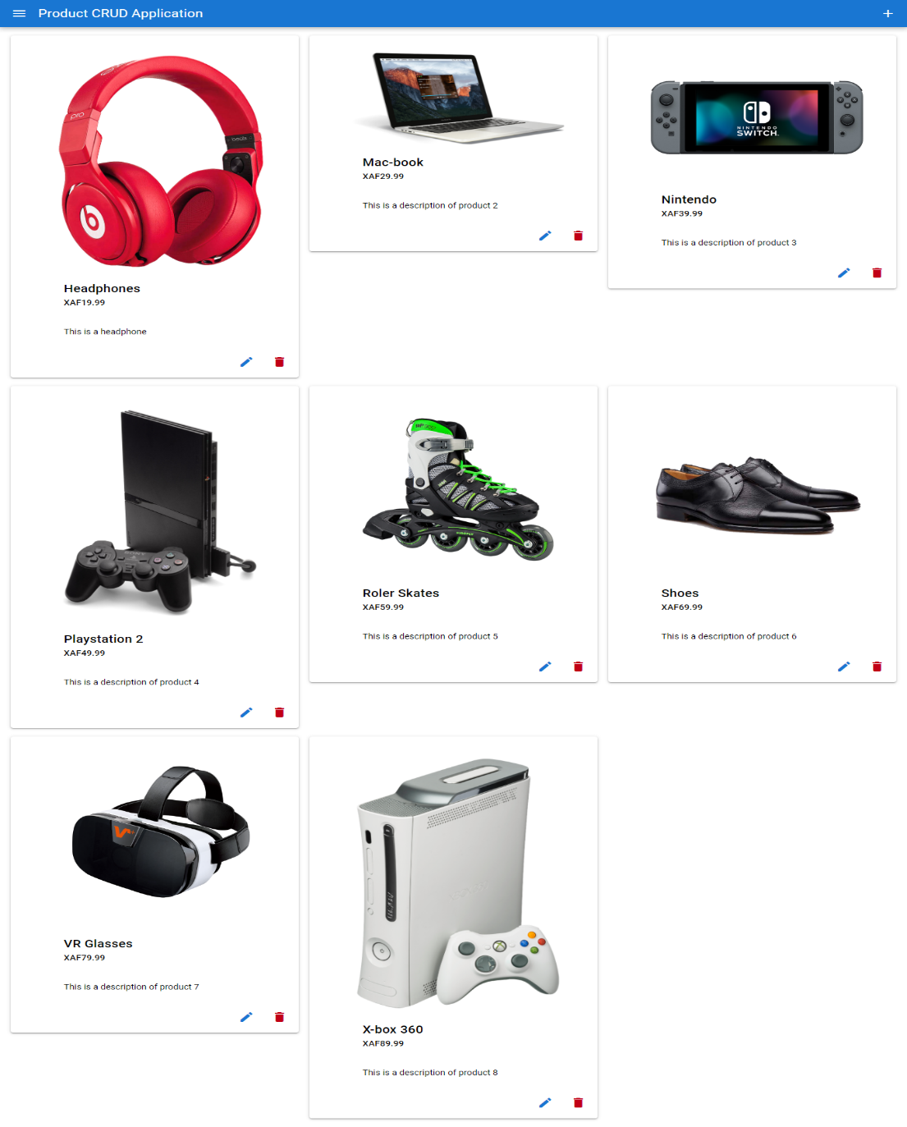

Figure 3: Quasar Crud Application Product Listing Page

### 2.4.3. Main Project: Academia V2

#### 2.4.2.1. Introduction

Academia V2, developed by Zinger Systems Ltd, is a comprehensive school management system that streamlines academic processes by automating administrative tasks and providing easy access to key data, helping institutions manage resources and focus on education.

#### 2.4.2.2. Background and Evolution of Academia

Academia is a school management software widely used in schools across the South West Region. The first version, Academia V1, was developed using outdated technologies like PHP 7.03 and Drupal, which are no longer supported. While functional, V1 has several drawbacks:

* Outdated Technologies: Limited security and maintenance support.
* No Mobile Compatibility: It cannot be converted into a mobile application.
* Restricted Growth: It lacks scalability and enterprise-level capabilities.

To overcome these issues, Academia V2 is being developed to modernize and improve the system. It aims to:

* Use updated technologies for better performance and security.
* Enable mobile app integration for easier access.
* Provide advanced features to support larger institutions and complex requirements.

#### 2.4.2.3.1. Problem Statement

Traditional school management practices often involve extensive manual processes, which can lead to inefficiencies, delays, and inaccuracies in reporting. These challenges hinder effective administration and can impact the overall educational experience. Academia V2 addresses these issues by implementing several key improvements:

* Automating repetitive tasks like attendance tracking, report generation, and fee management.
* Simplifying the retrieval of key statistical data.
* Ensuring that schools can produce accurate and timely academic reports.

#### 2.4.2.3.2. Requirement Gathering

The requirements for Academia V2 were primarily derived from feedback on Academia V1, ensuring that improvements were grounded in real-world use cases and experiences. The requirement-gathering process involved several key methods:

**1. User Reviews:** Insights from schools already using Academia V1 played a crucial role in identifying the system's limitations and areas for enhancement. This feedback provided a clear understanding of user pain points and successes, guiding our development priorities.

**2. Brainstorming Sessions:** Internal discussions at Zinger Systems Ltd facilitated collaborative idea generation and feature prioritization among team members. These sessions encouraged the exchange of diverse perspectives, allowing us to explore innovative solutions and determine which features would best meet user needs.

**3. Interviews & Surveys:** We engaged directly with educators and administrators from primary, secondary, and university institutions to gather valuable input on their expectations for the system and its usability. This direct feedback ensured that we understood the specific requirements and challenges faced by different educational stakeholders.

All requirement gathering was conducted by Zinger Systems Ltd, emphasizing our dedication to aligning Academia V2 with the evolving needs of educational institutions. This comprehensive and inclusive approach ensures that the software effectively supports educational management and enhances overall learning outcomes.

#### 2.4.2.3.3 Functional Requirements of Academia V2

**1. User Management**

* **User Authentication:** Secure login/logout for Admins, Staff, Students, and Guardians.
* **Role Assignment:** Assign specific roles and permissions to users (Admin, Staff, Student, Guardian).
* **Profile Management:** Update user details like name, email, phone, and location.

**2. Academic Structure Management**

* **Institution Setup:** Define institution details like name and location.
* **Faculty Management:** Add and manage faculties within the institution.
* **Department Management:** Create and manage departments within faculties.
* **Program Management:** Set up academic programs within departments.
* **Course Management:** Define and manage courses for programs, including assigning instructors.

**3. Classroom and Scheduling**

* **Timetable Management:** Assign and manage class schedules for students and staff.
* **Classroom Management:** Assign classrooms to courses and manage their capacities.
* **Class Scheduling:** Schedule specific classes with instructors and allocate classrooms.

**4. Attendance Tracking**

* Record attendance for scheduled classes.
* View and report attendance records for students.

**5. Grading and Performance**

* Exam Scheduling: Schedule exams for specific courses.
* Grading: Assign grades to students for exams or assignments.
* Score Management: Calculate raw scores and percentages for student assessments.

**6. Student Services**

* **Course Enrollment:** Allow students to enroll in courses within their program.
* **Fee Payment:** Enable students to pay tuition and other fees online.
* **Grade Viewing:** Allow students to view their grades and performance.
* **Schedule Access:** Provide students with access to their academic timetable.

**7. Guardian Features**

* View a student’s progress, including attendance and grades.
* Receive notifications about the student’s activities and updates.
* Communicate directly with staff regarding the student.

**8. Reporting and Analytics**

* Generate reports on student performance, attendance, and enrollment.
* Provide insights into academic trends for Admin and Staff.

**9. Administrative Control**

* Manage users and their roles across the platform.
* Monitor and oversee academic and operational reports.
* Create new programs, courses, and departments.

**10. Notifications**

* Notify users about key events (e.g., fee payment reminders, class schedules, and exam results).

#### 2.4.2.3.4. Non-Functional Requirements

Non-functional requirements define the quality attributes of the School Management System **,** ensuring the system meets performance, security, and usability standards. These requirements are essential for the system’s reliability and effectiveness.

**1. Performance & Scalability**

The system must efficiently handle multiple concurrent users, including students, teachers, and administrators, without performance degradation.

* The system shall support up to 5,000 concurrent users and respond to requests in less than 3 seconds.
* The database shall handle large datasets (e.g., student records, grades, attendance) without significant delays.
* Optimized queries shall ensure fast retrieval of student data and reports.

**2. Security & Data Privacy**

The system shall protect sensitive information, including student records, exam results, and personal data, from unauthorized access.

**3. Availability & Reliability**

The system must be available at all times, ensuring uninterrupted access to critical functions such as exam scheduling, grading, and attendance tracking.

Automatic failover mechanisms shall be implemented to ensure continuous operation during server failures and backed up.

**4. Usability & Accessibility**

The system must provide an intuitive and user-friendly interface for students, teachers, and administrators. It should also accommodate users with disabilities.

A mobile-responsive interface shall be implemented to enable students to access their profiles via smartphones and tablets.

Multi-language support shall be available to cater to a diverse student population.

**5. Maintainability & Extensibility**

The system should be easy to maintain and allow for future enhancements without major rework.

* The system shall be developed using a modular architecture, allowing new features to be added without disrupting existing functionalities.
* Version control mechanisms shall be implemented to track and manage system updates efficiently.

#### 2.4.2.3.5 Tech Stack of Academia V2

**a) Frontend Tools**

* Quasar Framework: Facilitates the development of responsive web apps with a strong integration of Vue.js.
* Vue.js: Handles the interactive and dynamic user interface components.
* SCSS (Sassy CSS): Enhances styling with features like variables, nesting, and promoting modular and maintainable code.
* TypeScript: Adds static typing to JavaScript for better debugging and maintainability

**b) Backend Tools**

* Parse Server: Manages APIs, database operations, and user authentication effectively.
* Firebase: Provides a real-time database and backend services for data synchronization.
* Firebase Authentication: Ensures secure, multi-method user authentication.
* Docker: Enables containerized development environments, making deployment more consistent and efficient

#### 2.4.2.4 System Design

The System Design section encompasses critical diagrams that illustrate the architecture and functionality of the Academia V2 system, which is designed to serve primary, secondary, and university institutions. The entities represented in this report are based on a university scenario, yet the names and structures are synonymous across various educational institutions, as per the standards set by the Ministry of Education. This alignment ensures that the system can be effectively adapted to different educational contexts.

Included in this section are the following diagrams:

1. **Use Case Diagram:** This diagram captures the interactions between users and the system, detailing the different user roles and the functionalities available to each. It serves to clarify the primary use cases and the system's intended user experience.
2. **Class Diagram:** This diagram outlines the system's data structures, illustrating the relationships between various classes and their attributes. It provides insight into how the system organizes its data and functionalities.

While these diagrams are integral to understanding the system's design, the Entity-Relationship (ER) diagram has been deliberately excluded from this report. This decision is in line with company policies that aim to protect sensitive information and prevent potential security vulnerabilities. The exclusion of the ER diagram ensures that the internal data relationships and structures remain confidential, safeguarding the system against any potential threats from competitors or malicious actors.

Here’s a table illustrating the equivalent entities for primary and secondary schools in Cameroon compared to those for universities:

|  |  |  |  |
| --- | --- | --- | --- |
| Entities | University | Secondary School | Primary School |
| Faculty | Faculty (e.g., Science, Arts) | N/A | N/A |
| Programme | Degree Programme (e.g., BSc, BA) | Stream (e.g.,  Science, Arts) | N/A |
| |  | | --- | | Department |  |  | | --- | |  | | Department (e.g., Computer Science, Biology) | Subject Area (e.g., Mathematics, English) | Subject Area (e.g., Mathematics, English) |
| |  | | --- | | Classroom |  |  | | --- | |  | | Lecture Hall/Room | Classroom | Classroom |
| Semester | Semester | Term | Term |
| Level | Level 100, Level 200, Level 300 (Years of Study) | Level (e.g., Form 1, Form 2) | Level (e.g., Class 1, Class 2) |
| Course | Course (e.g., Data Structures, Chemistry) | Subject (e.g., Physics, History) | Subject (e.g., Science, Art) |
| Class | N/A | Class (e.g., Form 1A, Form 1B) | Class (e.g., Class 1A, Class 1B) |

Table 1: Entities Synonym names across University, Secondary and Primary Schools

##### 2.4.2.4.1 Use Case Diagram

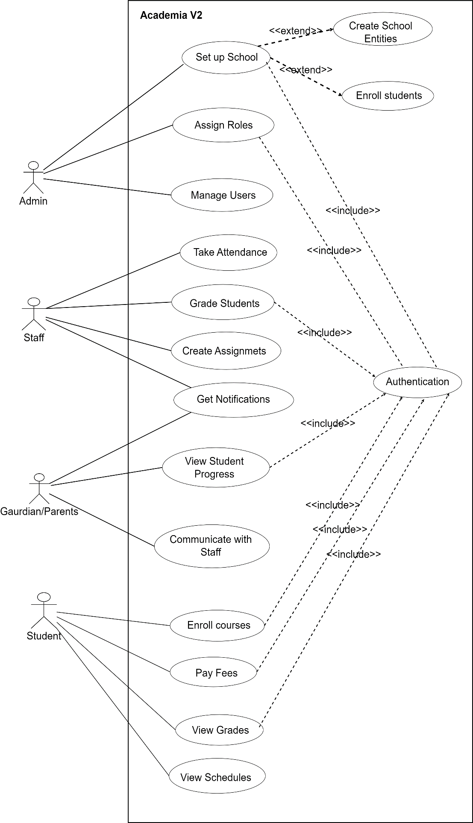

Figure 4: Use Case Diagram

###### 2.4.2.4.2 Use Case Diagram Description

**A. Actors (Users)**

**I. Primary Actors**

1. **Admin**

* Manages users, programs, and departments.
* Assigns roles and oversees reports.
* Set up the institution's academic structure.

1. **Staff**

* Manages academic tasks like attendance, assignments, and schedules.
* Views and grades student performance.

1. **Student**

* Enrolls in courses and accesses grades.
* Pays fees and views schedules.

1. **Guardian**

* Monitors student progress.

**B. Use Cases (For Primary Actors)**

1. **Admin Use Cases**

* Manage Users: Add, update, or remove users in the system.
* Assign Roles: Assign roles to staff, students, or other users.
* View Reports: Access reports on system usage, performance, or attendance.
* School Setup: Define the school structure such as programs, departments, courses, faculties, levels, and classrooms, and handle all student enrollments.

1. **Staff Use Cases**

* Assign Timetable: Allocate classes and timetables for students.
* View Student Grades: Check and update student performance.
* Take Attendance: Record attendance for scheduled classes.
* Create Assignments: Assign and manage coursework for students.

1. **Student Use Cases**

* Enroll in Courses: Register for courses under a program.
* View Grades: Check grades for completed exams and assignments.
* Pay Fees: Make tuition and other fee payments.
* View Schedule: Access the academic timetable.

1. **Guardian Use Cases**

* View Student Progress: Check grades, attendance, and performance of their ward.
* Receive Notifications: Get updates on attendance, grades, or fee payments.
* Communicate with Staff: Interact with staff regarding the student’s progress.

**C. Relationships Between Actors**

|  |  |  |
| --- | --- | --- |
| **Actors** | **Relationship** | **Description** |
| Admin ↔ Staff | <<communicates>> | Admin assigns roles, Staff reports issues. |
| Admin ↔ Student | <<manages>> | Admin creates student accounts. |
| Admin ↔ Guardian | <<communicates>> | Admin provides Guardian access to student records. |
| Admin ↔ System | <<controls>> | Admin configures system settings. |
| Staff ↔ Student | <<interacts>> | The staff teaches, evaluates, and grades students. |
| Staff ↔ Guardian | <<communicates>> | Staff sends student reports to the Guardian. |
| Student ↔ Guardian | <<associated>> | Guardian monitors student’s progress. |
| |  | | --- | | Student ↔ System |  |  | | --- | |  | | <<uses>> | Student enrolls in courses, and views schedules. |
| Guardian ↔ System | <<uses>> | Guardian tracks student performance. |
| Staff ↔ System | <<uses>> | |  |  | | --- | --- | | Staff manages attendance and assignments. |  | |

Table 2: Relationship Between Actors

##### 2.4.2.4.3. Class Diagram

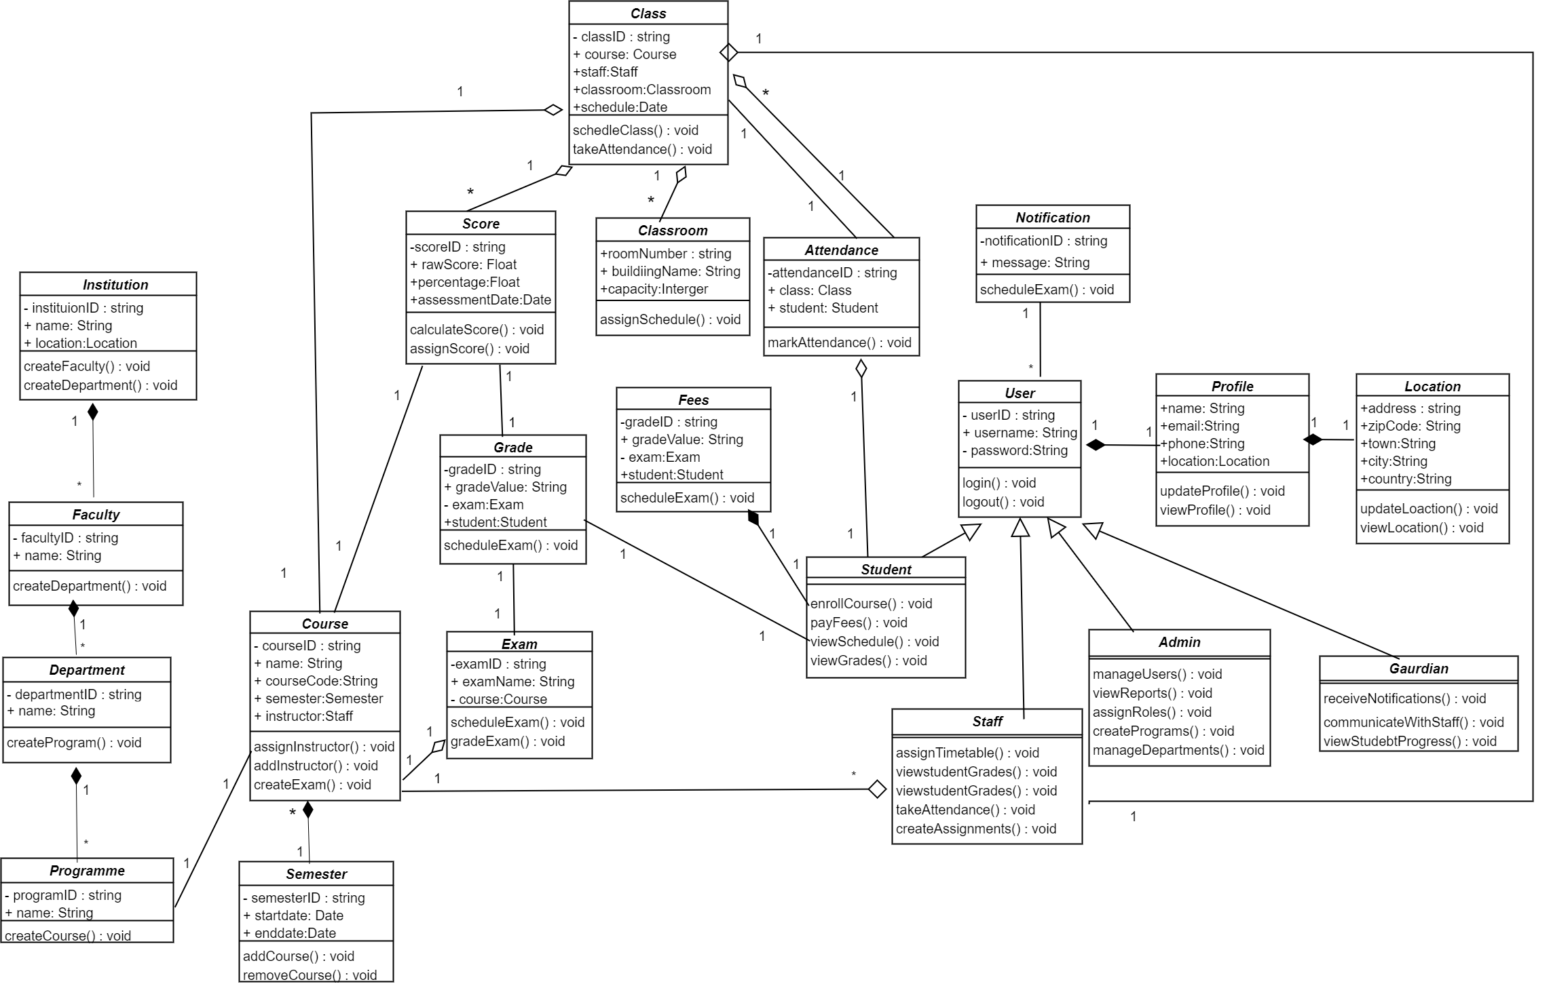

Figure 5: Academia V2 Class Diagram

###### A. Classes, Attributes and Methods

|  |  |  |  |
| --- | --- | --- | --- |
| **S/N** | **Classes** | **Attributes** | **Methods** |
| 1 | User Class | userID  username  password | • login(): Logs in the user.  • logout(): Logs out the user. |
| 2 | Admin Class | inherits from User | • manageUsers(): Add, edit, or delete user accounts.  • assignRoles(): Assign roles to users.  • viewReports(): View system reports.  • createProgram(): Add new programs.  •manageDepartments(): Manage academic departments. |
| 3 | Staff Class | inherits from User | • assignTimetable(): Schedule classes.  • view student grades (): Access grade records.  • takeAttendance(): Record attendance.  • createAssignments(): Assign student tasks. |
| 4 | Student Class | Inherits from User | • enrollCourses(): Register for courses.  • viewGrades(): View grades.  • payFees(): Pay fees.  •viewSchedule():Check class schedules. |
| 5 | Guardian Class | Inherit from User | • viewStudentProgress(): Monitor student performance.  • receiveNotifications():Get updates about the student  communicateWithStaff(): Contact staff. |
| 6 | Profile Class | name, email, phone, Location | updateProfile(): Edit profile details.  viewProfile(): View profile details. |
| 7 | Location Class | address, zipCode, country, town, city | updateLocation(): Edit location details.  viewLocation(): View location details. |
| 8 | Course Class | courseID, name, semester, instructor, program | assignInstructor(): Link course to instructor.  addStudents(): Enroll students. |
| 9 | Semester Class | semesterID, startDate, endDate | addCourse(): Add course to the semester.  removeCourse(): Remove course from the semester. |
| 10 | Program Class | programID, name, department | addCourse(): Add courses to the program. |
| 11 | Department Class | departmentID, name | addProgram(): Link program to the department. |
| 12 | Classroom Class | roomNumber, building, capacity | scheduleClass(): Assign classes to the room. |
| 13 | Class Class | classID, course, staff, classroom, schedule | scheduleClass(): Assign class time and room.  takeAttendance(): Record student attendance. |
| 14 | Exam Class | examID, examDate, course | scheduleExam(): Assign exam dates.  gradeExam(): Assign exam grades. |
| 15 | Grade Class | gradeID, gradeValue, exam, student | assignGrade(): Assign grades to students |
| 16 | Attendance Class | attendanceID, class, student | markAttendance(): Record attendance. |
| 17 | Fee Class | feeID, amount, status, dueDate | payFee(): Process payments.  applyFine(): Add fines for late payments. |

Table 3: Classes, Attributes and Methods

#### Tasks Performed on Academia V2(Implementation)

This section gives all frontend and backend tasks for Academia Version 2 assigned and executed during the internship. These tasks played an important role in moving the project forward as we interns participated in maintaining and developing Academia V2’s features. Here is a rundown of these tasks :

##### I. Frontend Tasks

**1) Login Page**

One of the tasks involved designing the Login Page, which included creating a seamless transition between the login and sign-up options. The design prioritized responsiveness, ensuring optimal display and functionality across various devices, including desktops, laptops, tablets, and mobile devices. This approach not only enhanced user experience but also facilitated easy access for all users, aligning with modern web design standards



Figure 6: Academia Login Page

**2) Analytic Widgets**

The analytic widgets provide users with an interactive experience by visually displaying data from registered institutions across various models. These widgets also enable users to perform actions related to the data they represent. The widgets have donut charts, progress bars, graphs, and color indicators, which change based on the data from the virtualized model. Here is a list of widgets personally assigned to me

1. **Student Enrollment Widget**: Displays the number of male and female students, along with the total enrollment, using a dual progress bar and donut chart.
2. **Staff Overview Widget:** Shows the number of male and female staff, total lecturers, and staff statuses, displayed in a donut chart.
3. **Hostel/Dormitory Occupancy:** Displays occupancy details for male and female dorms, including the number of occupied beds, shown in a donut chart for boarding schools.



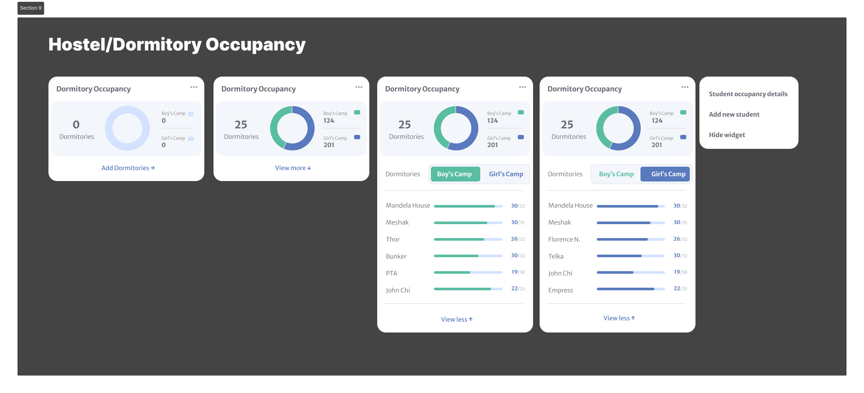

Figure 7:Hostel/Dormitory Occupancy Widget

**3) Institution Models**

Academia V2 has multiple institutional models that facilitate management and the sole purpose of the application. These institution models comprise three UI pages designed along with them which are :

* The Listing Page: The listing page contains a table showing all the model items against their attributes such as a level model has a level name, code, and description.
* The Form: This UI component allows users to enter, edit, and save data for various models. It supports CRUD operations and is designed as a right-hand side drawer, activated during editing and creating actions.
* The Details Page: The details page gives more information about every respective table data in the listing page such as getting details about a specific table data in the listing pages table.

The institution models which I worked on include: -

* Level Model Pages: Manages educational levels (e.g., first year, second year) with parameters like level name, code, and description.
* Assessment Model Pages: Manages evaluations (tests, assignments, exams) with parameters like types, weights, and grades.
* Guardian Model Pages: Captures guardian details, including contact information and relationships for communication with families.
* Bed Model: Tracks student accommodation, including dormitory and bed assignments for efficient space management.
* Seat Model: Manages the number of seats available in each classroom.
* Class Model: Stores the classes that belong to the educational institution, which in turn helps with class management.

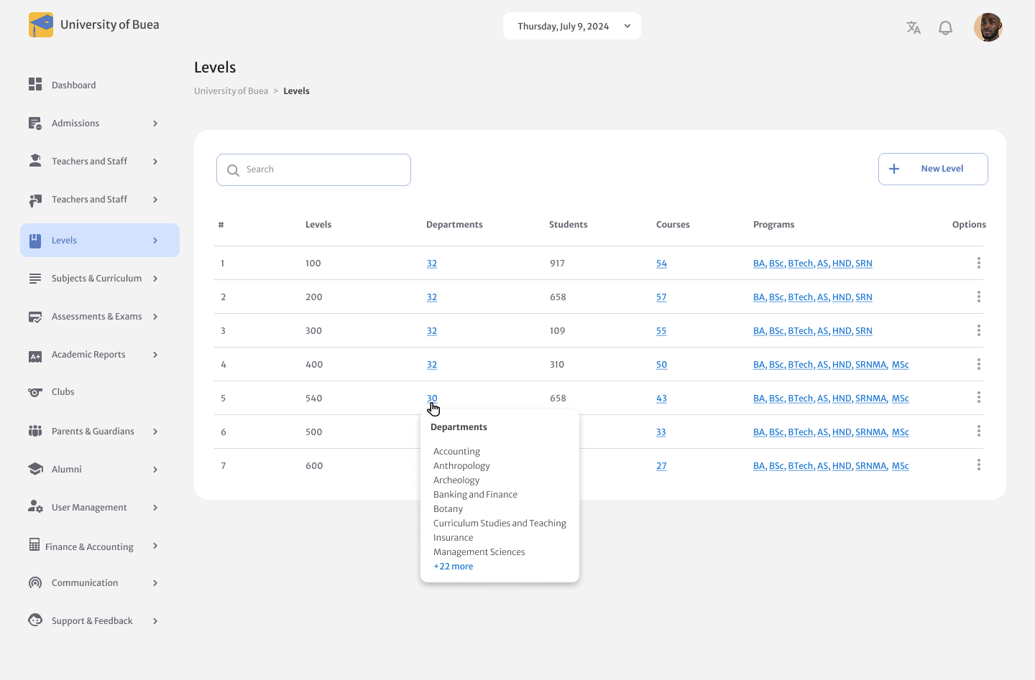

Figure 8: Level Listing Page with Sidebar Menu

**4) Designing Admin Dashboard Components**

1. **Video Tutorial Playback:** The video tutorial playback assists admins in using the software. The admin can watch videos within the web app guiding him/her on how to setup a school and do certain actions like register a course.
2. **Dashboard Widgets:** Developed and styled admin widgets for improved functionality and user interaction. The admin uses these widgets to monitor staff activity, student activity and task status.

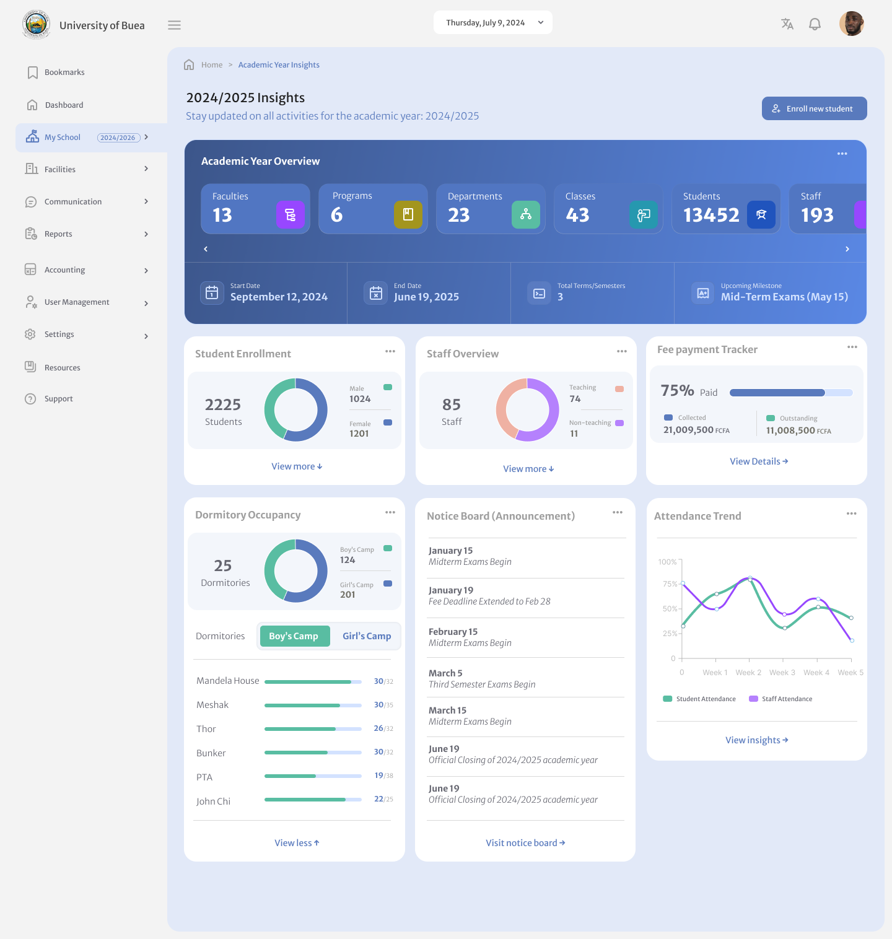

Figure 9:Academia Admin School Dashboard

##### II. Backend Tasks for Academia V2



**1)Archiving Functionalities:**

I implemented archiving features to efficiently manage and store data. This involved:

* Creating systems to manually archive old or unused data to free up storage space.
* Ensuring the archived data is easily retrievable when needed, without compromising system performance.

**2)CRUD Operations**

Performed CRUD operations onmodel pages that create, read, update, and delete functionalities on various models. These operations allow the administrator to setup, create, and manage the school.

**3) Import and Export Functionalities**

Performed a feature toimport and export lists as Excel sheets**,** allowing users to upload an Excel file to populate data and download lists while ensuring proper formatting, validation, and a user-friendly interface. This feature enables users to export reports on students, classes, departments and much more.

**4) Search Queries**

Performed search queries by name, by code, and by status (enabled, deleted, and archived) for various models worked on. This makes users search classes (courses, faculties, etc.) by their attributes (name, code, status) and get results.

**5)Timeline Filter**

This functionality allows users to query data based on a selected date, ensuring only relevant rows are displayed. It filters data by comparing the selected date with the current date, retrieving only matching records. This improves efficiency by reducing unnecessary data load and dynamically updates whenever the selected date changes, ensuring the table stays updated.

## 2.5 Task Execution

This section provides a detailed overview of the **planning, development methodology**, and **system architecture** of Academia V2.

### I. Planning

Clear goals and realistic deadlines were set using Agile principles, ensuring flexibility and iterative progress. The planning phase included requirement gathering, risk assessment, and task prioritization, helping the team stay focused and on schedule for timely delivery.

### II. Methodology

The project followed Agile using Scrum, which enabled collaboration, adaptability, and continuous improvement.

* **Sprint Planning:** Tasks were broken down into smaller units, making it easier to manage progress and address challenges.
* **Daily Stand-ups:** Regular check-ins promoted transparency and quick issue resolution among team members.
* **Sprint Reviews & Retrospectives:** Evaluated completed work, gathered feedback, and identified areas for improvement to enhance future sprints.

### III. Architecture

The project adopted MVVM (Model-View-ViewModel) for clear separation of concerns:

* Model: Handles data and business logic (API interactions, state management).
* View: Displays UI using Quasar’s components.
* ViewModel: Manages application state and UI behavior.

Additionally, a Component-Based Architecture ensured modular, reusable UI components for scalability and easier maintenance. When integrated with the backend, MVC (Model-View-Controller) was used:

* Model: Manages data processing.
* View: Quasar frontend displays data.
* Controller: Processes requests and updates the Model.

Combining MVVMon the frontend and MVC on the backend ensures a maintainable and scalable solution.

## 2.6 Workplace Relationships

Building and nurturing relationships at the workplace was a critical aspect of my internship. These relationships not only enriched my experience but also contributed to my professional growth.

1. **Relationship with Supervisors:**

* Maintained a professional relationship with my technical supervisor, whose feedback and mentorship were crucial, especially during the dashboard development project.
* My academic supervisor, Prof. Elie Fute, ensured my internship aligned with academic goals and provided insights during reviews.

1. **Relationship with Team Members:**

* Team members were supportive and approachable. Participating in activities like the Friday Share and company outings fostered a sense of belonging and improved team dynamics.

1. **Relationship with Other Interns:**

* Collaborating with fellow interns allowed us to share ideas and experiences. We brainstormed features during the initial phases of the mobile task management app, enhancing our collective learning.

# Chapter 3: Extra-Curricular Activities

## 3.1 Activities Organized by the Company

**Extra-Curricular Activities at Zinger Systems Limited**

Zinger Systems Limited organizes various activities to foster teamwork, build a strong work culture, and ensure mutual understanding among employees. These activities clarify shared goals and encourage collaboration. Below is a brief description of each activity:

1. **Friday Share**Every Friday, the team gathers to reflect on the week’s progress. Discussions focus on achievements, challenges, and ways to overcome setbacks
2. **End of Year Gathering**  
   The company schedules an end of year outing annually to celebrate company success and get an overview on goals for the upcoming year.
3. **New Man Task**  
   A unique cultural activity where new team members, whether interns or full-time employees are welcomed into the company. They show appreciation to their predecessors by offering treats or organizing an outing, fostering inclusivity and camaraderie.
4. **Spontaneous Events**These sort of events come unexpected like birthday parties, weddings and contract success parties. These events highly contribute to bond with team mates.
5. **Company Outings**Occasional outings are organized to encourage relaxation, strengthen interpersonal relationships, and improve team dynamics in a non-work setting.

## 3.2 My Role in the Activities

I actively took part in theFriday Share and Monday Share meetings, where I shared updates on my tasks, discussed any challenges I was facing and suggested ways to improve our workflow. As a new intern, I also joined the New Man Task by offering treats to my colleagues, which helped me build connections and feel more integrated into the team. During Company Meetings, I contributed feedback on ongoing projects and learned from the valuable insights shared by my more experienced teammates. Finally, I enjoyed participating in Company Outings, which gave me the chance to bond with my colleagues outside of work and get to know the team better.

## Administrative Task with Managers

During my internship at Zinger Systems Limited, managers were supported with various administrative and professional tasks. These included:

* Assisting with Meetings: Helped organize team meetings, ensuring materials were prepared and available for participants.
* Documentation: Drafted reports on task progress and challenges to guide decision-making and improve timelines on Excel sheets for tracking.
* Project Coordination: Collaborated with managers on Academia V2, providing progress updates and aligning deliverables with company goals.

## 3.4. Lessons and Benefits

Participating in various activities at Zinger Systems Limited provided me with valuable lessons and professional growth:

**1. Skill Development:**

* Teamwork: Collaborating with colleagues during activities like Monday Share and Friday Share strengthened my ability to work in diverse teams.
* Communication: Sharing ideas and discussing setbacks in team meetings improved my ability to express thoughts clearly and constructively.

**2. Networking and Connections:**

* Engaging in team activities, such as company outings and the New Man Task, helped me build relationships with colleagues, creating a supportive professional network.

**3. Professional Insights:**

* These activities offered a deeper understanding of workplace dynamics, emphasizing the importance of shared goals, mutual respect, and fostering a positive work culture.

# Chapter 4: Difficulties and Challenges Encountered

During the internship at Zinger Systems Limited, several challenges were faced that helped professional grow. This section highlights the difficulties encountered and how they were addressed them.

**1. Technical Challenges**

* **Learning New Tools:** I had to quickly learn frameworks like Next.js and BEM architecture, which I hadn’t used before.

**Solution:** Studied online resources and asked colleagues for guidance.

* **Debugging Issues:** Errors in CRUD functionality and local storage integration slowed progress.

**Solution:** Collaborated with teammates and used technical forums.

**2. Task Management**

* **Balancing Assignments:** Managing multiple projects, including the mobile app and dashboard, was difficult.

**Solution:** Prioritized tasks and set milestones to stay on track.

* **Understanding Requirements:** Some task instructions were unclear at first.

**Solution:** Sought clarification from my supervisor to ensure accuracy.

**3. Communication Challenges**

* **Team Collaboration:** Coordinating with team members online sometimes causes delays.

**Solution:** I used company tools like Discord and WhatsApp to improve communication.

* **Handling Feedback:** Implementing feedback effectively was challenging at first.

**Solution:** I took notes during feedback sessions and worked systematically to make changes.

**4. Time Management**

* **Meeting Deadlines**: Some tasks took longer than expected due to unforeseen challenges.

**Solution:** I allocated extra time and tracked progress using task management tools.

# Chapter 5: Conclusion and Recommendations

## 5.1. Conclusion

The internship at Zinger Systems Limited was an invaluable experience that allowed me to bridge the gap between academic learning and professional practice. I gained hands-on exposure to frontend and backend development, enhanced my technical and problem-solving skills, and adapted to a professional work environment. The challenges I encountered helped me build resilience, while the guidance from my supervisor and collaboration with team members significantly contributed to my growth as a software developer. This experience has solidified my confidence in pursuing a career in software engineering.

## 5.2 Recommendations

### 5.2.1 For the Company:

* Enhance onboarding processes by providing detailed documentation or tutorials on tools and frameworks.
* Foster more structured mentorship programs to guide interns through complex tasks.
* Encourage regular feedback sessions to ensure clarity on expectations and progress.

### 5.2.2 For Future Interns:

* Be proactive in seeking guidance and learning new technologies.
* Manage time effectively by breaking down tasks into smaller, manageable steps.
* Maintain open communication with supervisors and team members for better collaboration.

### 5.2.3 For Academic Institutions:

* Collaborate with companies to align internship objectives with academic curricula.
* Prepare students for real-world tasks by introducing industry-relevant tools and frameworks in coursework.
* By addressing these recommendations, the internship experience can be more effective and rewarding for all parties involved.

# References

Atlassian. (2024). What is BEM methodology? Retrieved from <https://www.atlassian.com/git/tutorials/what-is-bem>

Bass, L., Clements, P., & Kazman, R. (2012). Software architecture in practice. IEEE Software, 29(4), 16-18. <https://doi.org/10.1109/MS.2012.34>

Expo Documentation. (n.d.). Using Expo for React Native development. Retrieved from <https://docs.expo.dev/>

Greenfield, J., & Short, K. (2004). Software factories: Assembling applications with patterns, models, frameworks, and tools. Software Development Journal, 12(3), 35-42. <https://doi.org/10.1016/j.software.2004.01.005>

Martin, R. C. (2008). Clean code: A handbook of agile software craftsmanship. Prentice Hall.

Roberts, D. M., & Johnson, R. E. (2005). Strategies for refactoring software. In Proceedings of the 5th International Conference on Agile Development (pp. 100-112). IEEE. <https://doi.org/10.1109/AGILE.2005.100>

Somerville, I. (2020). Software engineering (10th ed.). Pearson.

University of Buea. (2023). Department of Computer Engineering internship guidelines. Retrieved from <https://www.ubuea.cm/>

World Economic Forum. (2023). The impact of technology on workplace collaboration. Retrieved from <https://www.weforum.org/>

Zinger Systems Limited. (2023). Annual report on in-house software development projects. Buea, Cameroon: Zinger Systems Ltd.

# Appendices

More pictures from the document’s content

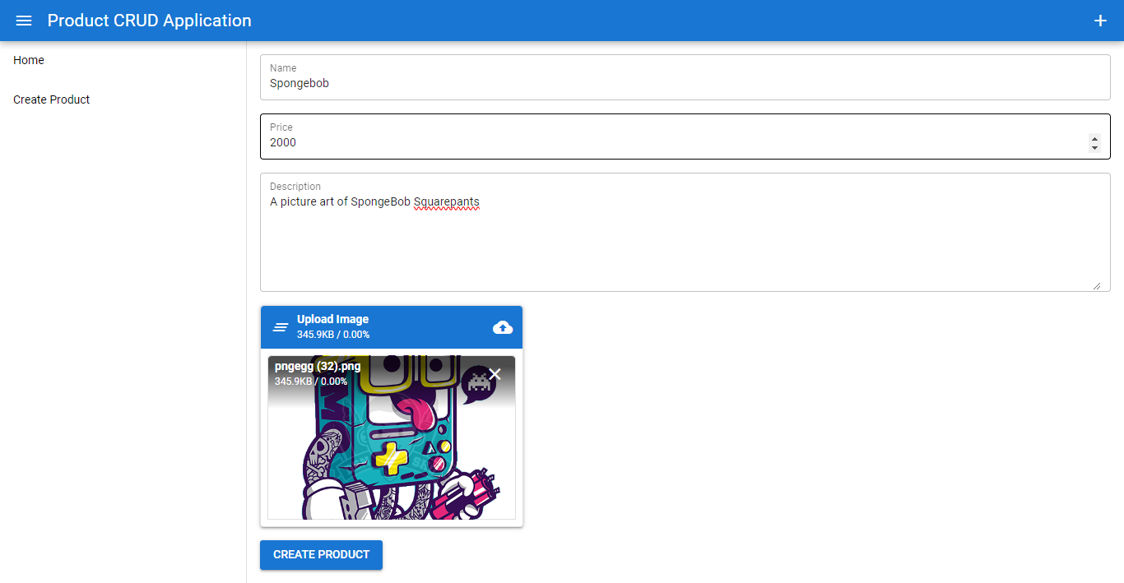

Figure 10: Quasar CRUD App (Creating Product)

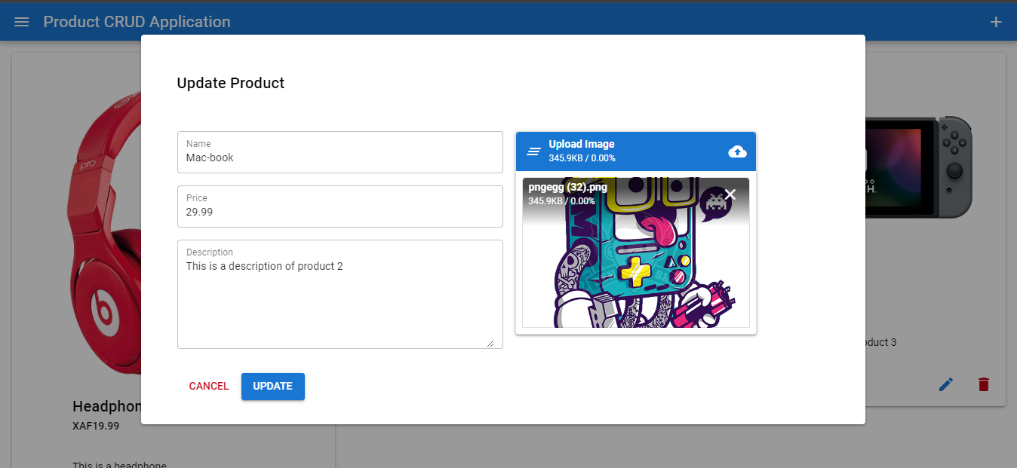

Figure 11: Quasar CRUD App (Update Product)

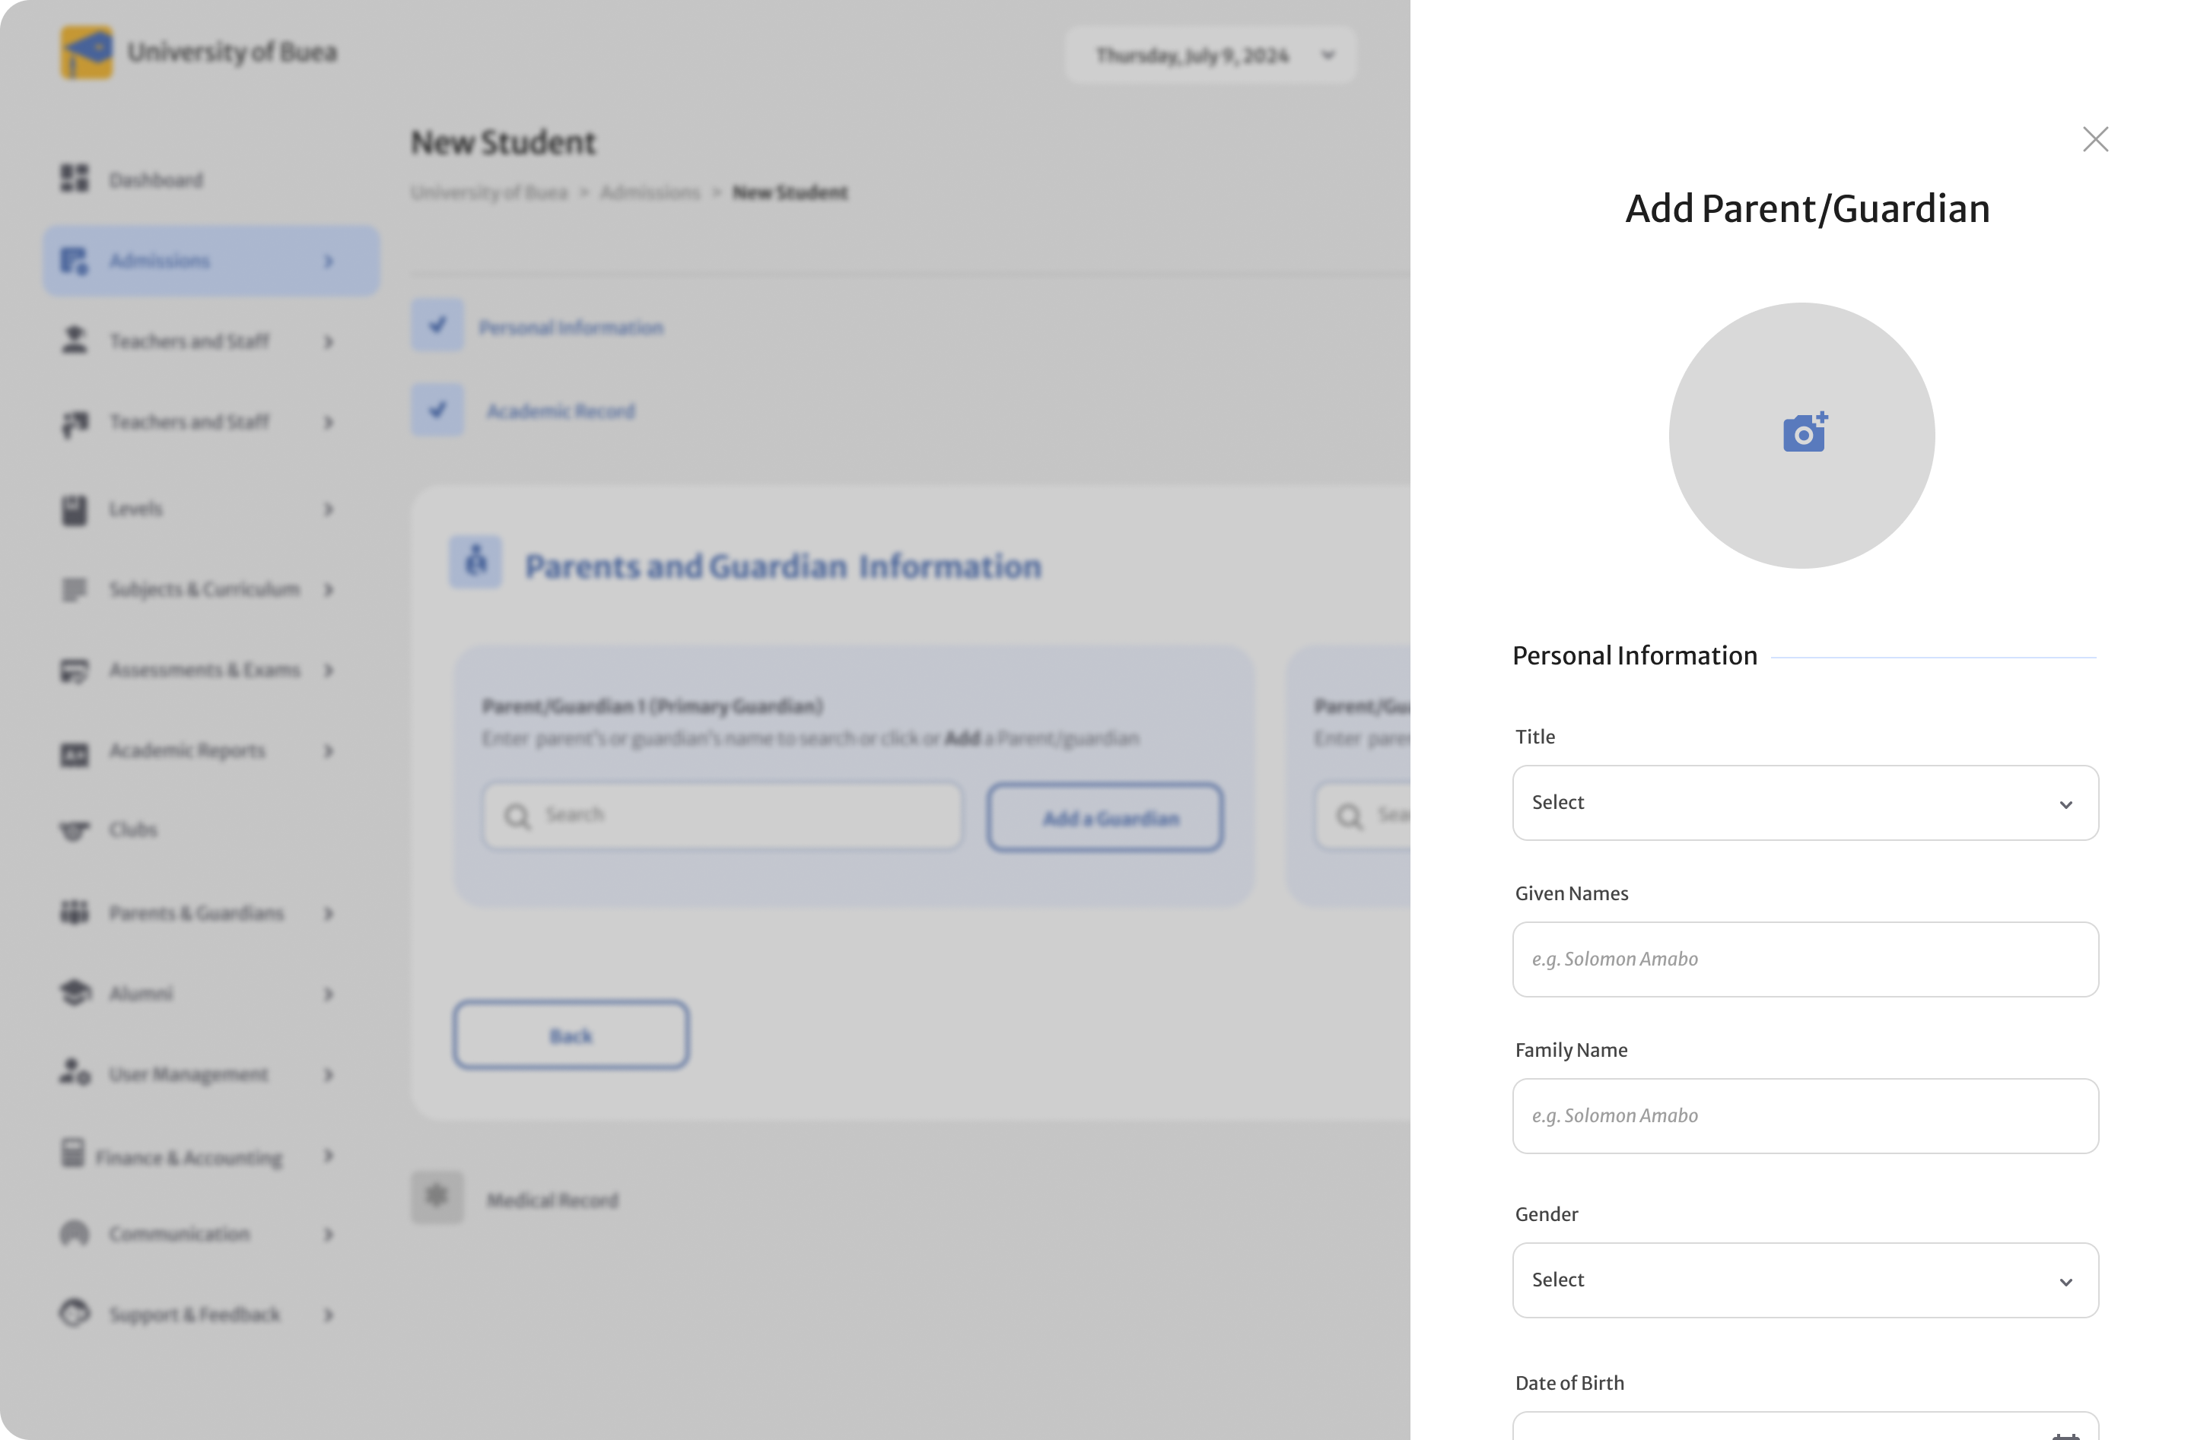

Figure 12: Gaudian Model (Form Active Mode)

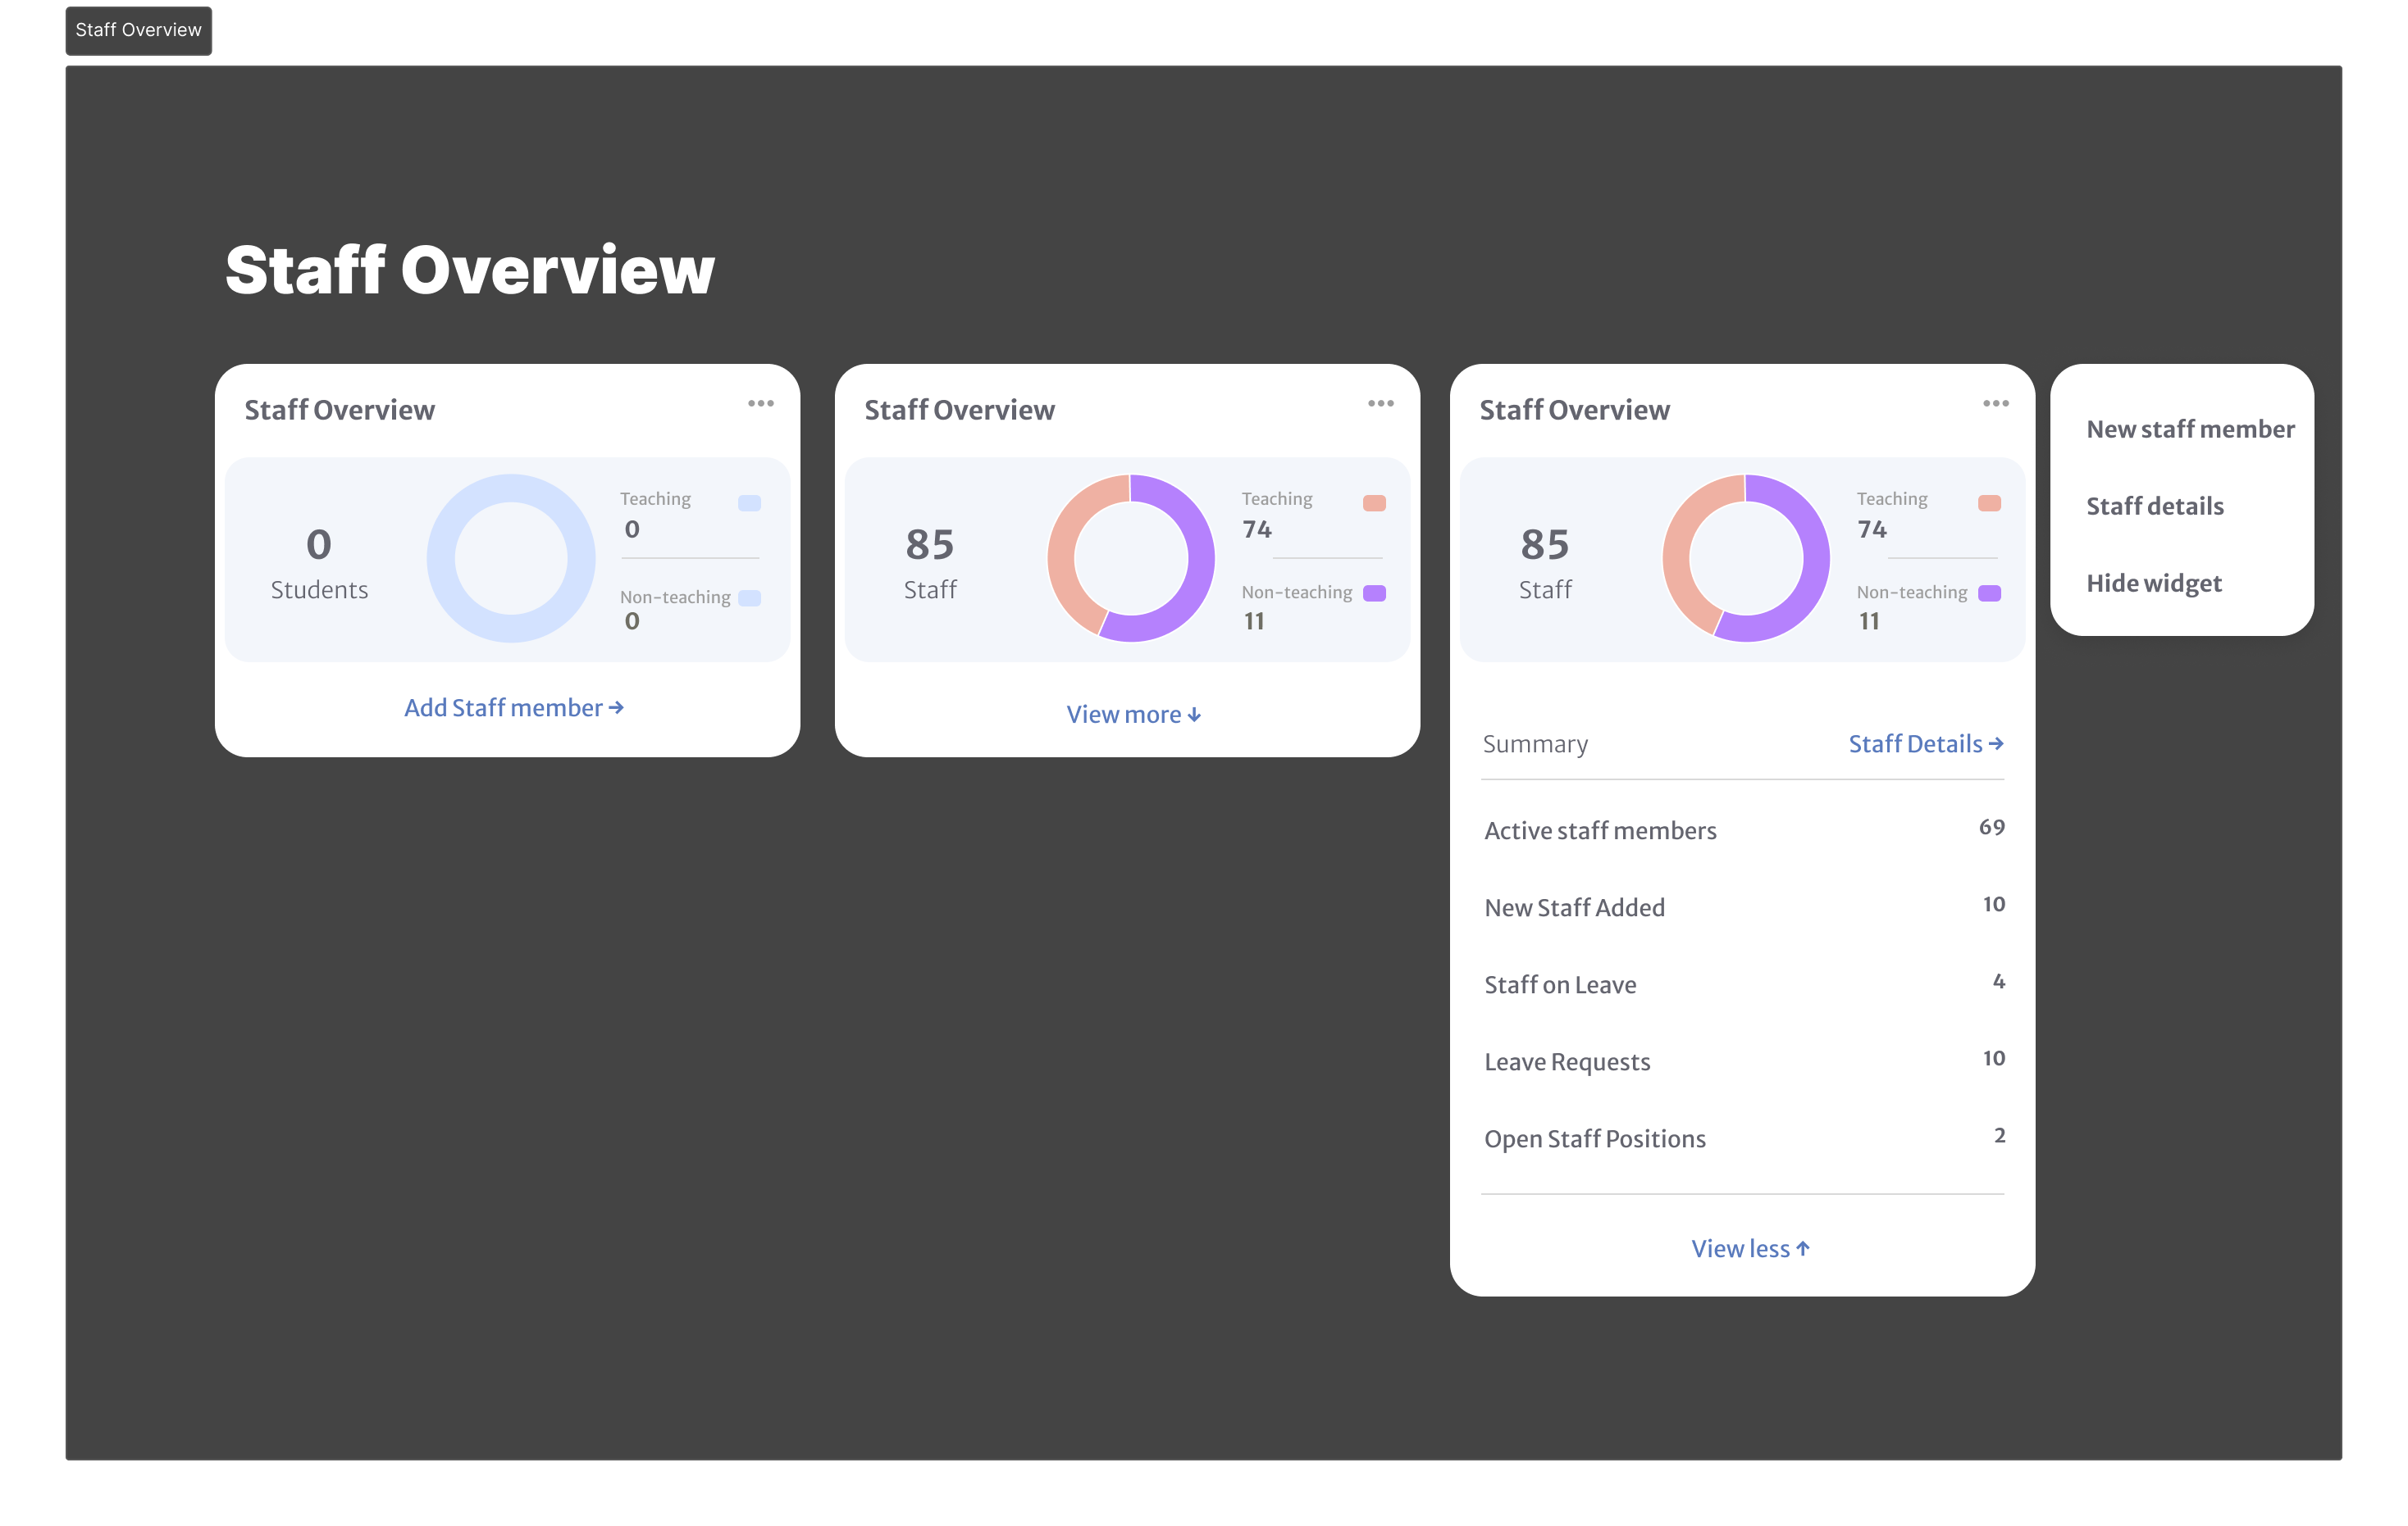

Figure 13: Staff Overview Widget

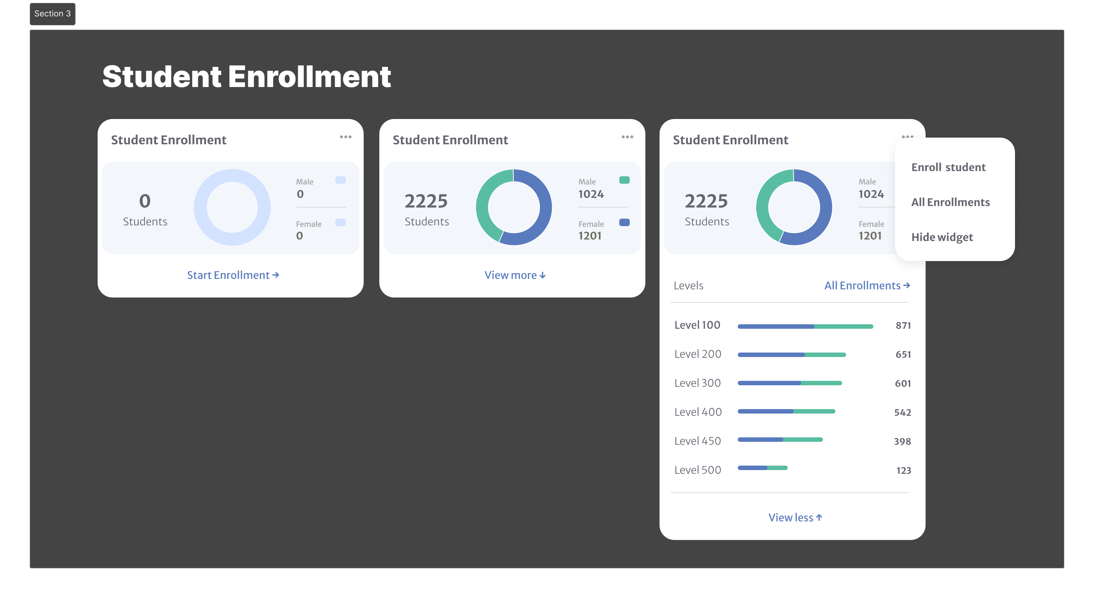

Figure 14: Student Enrollment Widget

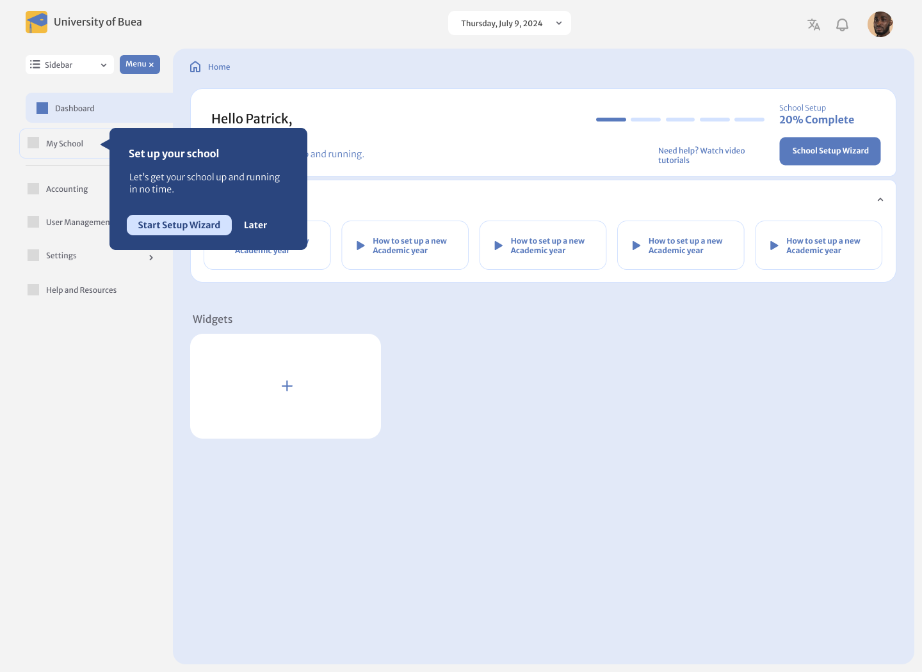

Figure 15: Academia Admin Dashboard (School Setup)

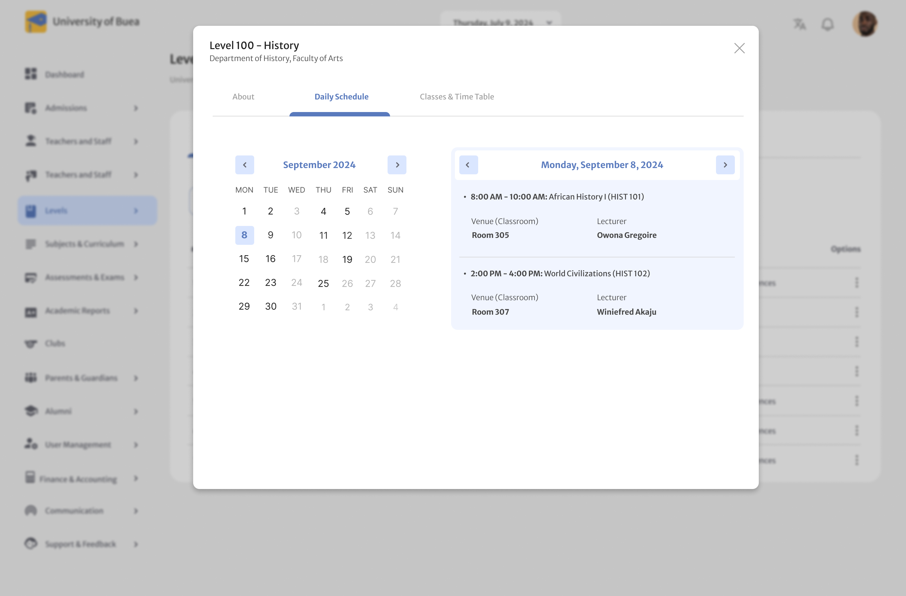

Figure 16: Academia Level Schedular Pop-up Modal

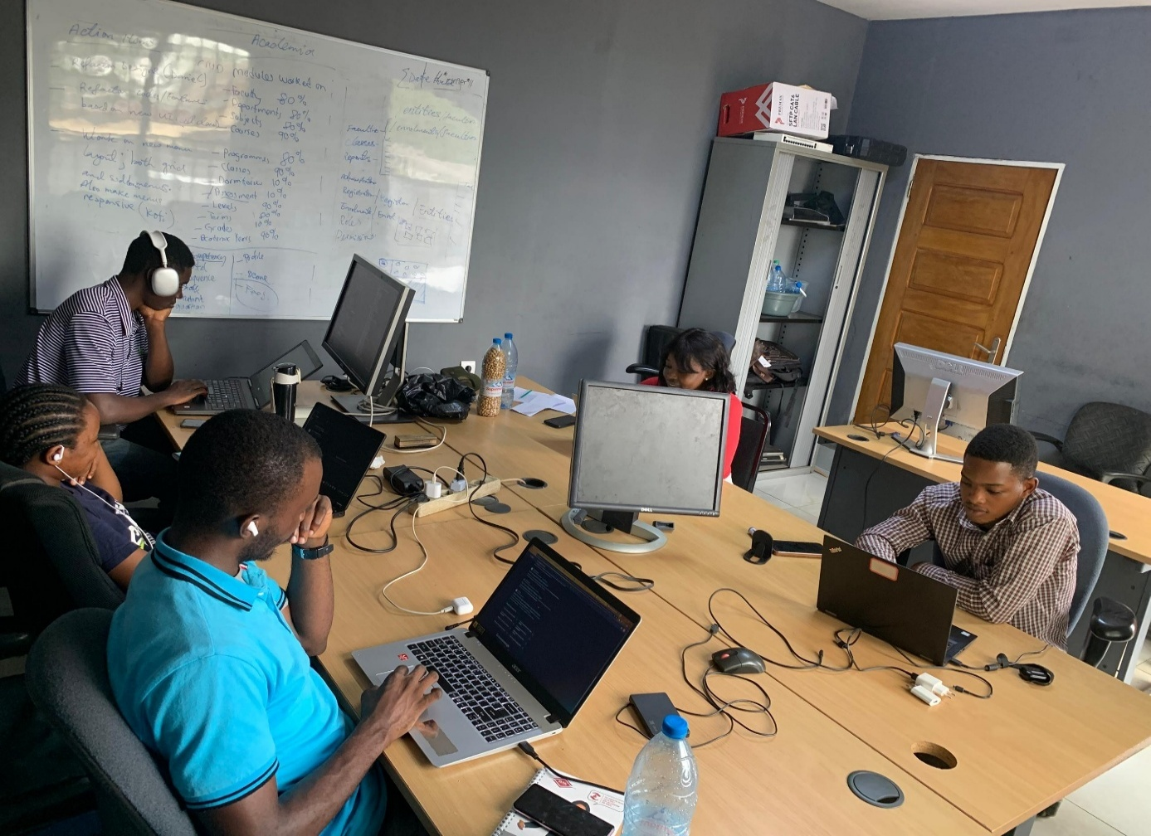

Figure 17: Working day at the office



Figure 18: End of Year Outing (Extracurricular Activity)